Day 11 Task:

1. Created a dev Compile build to test maven sample code.

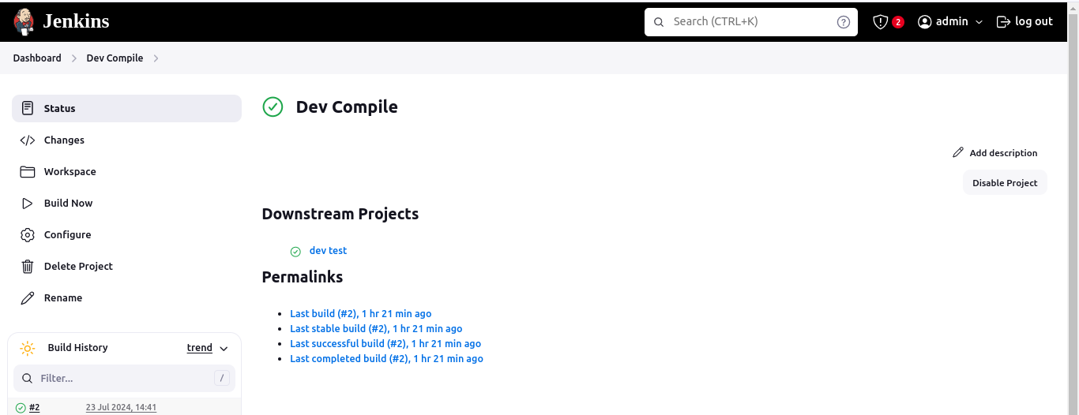.

After the successful build of dev compile it will build dev test as i have added post build actions

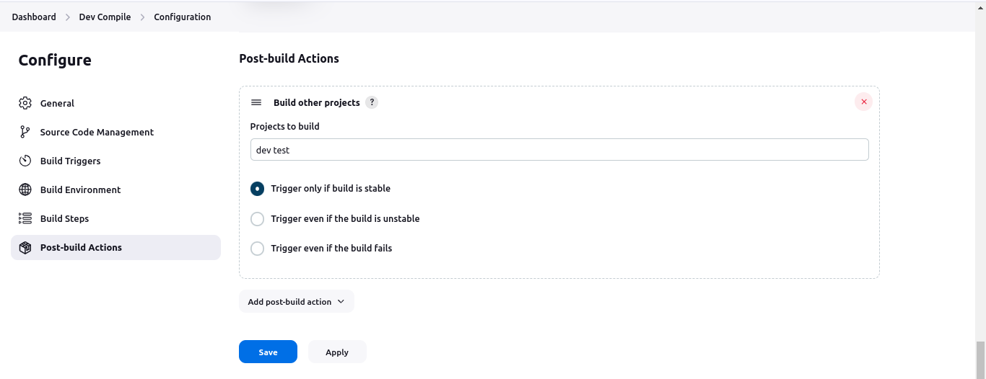.

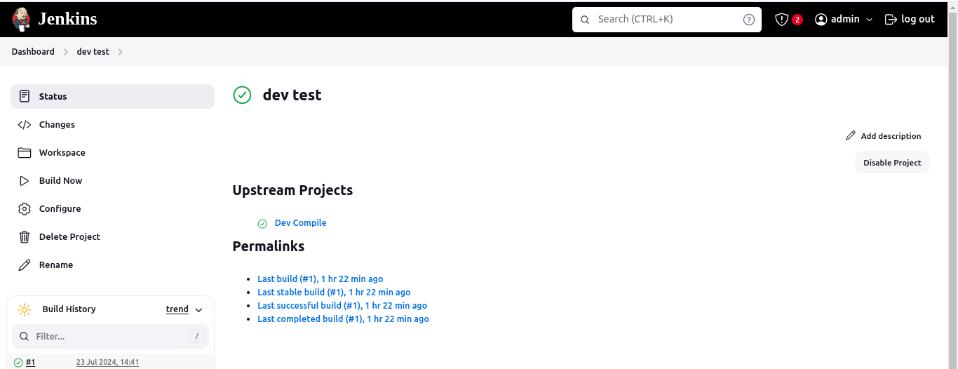.

2. Create a private repo for adding credentials to access GitHub private Repo.

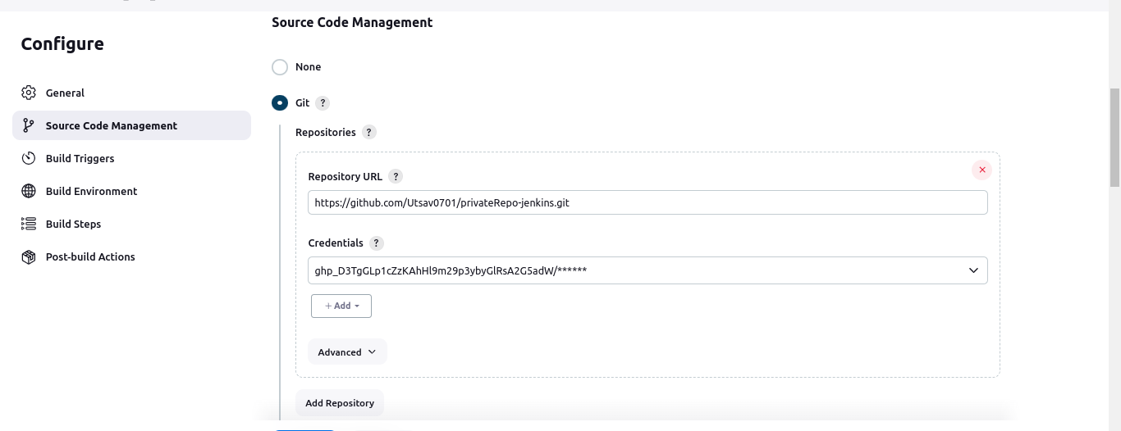.

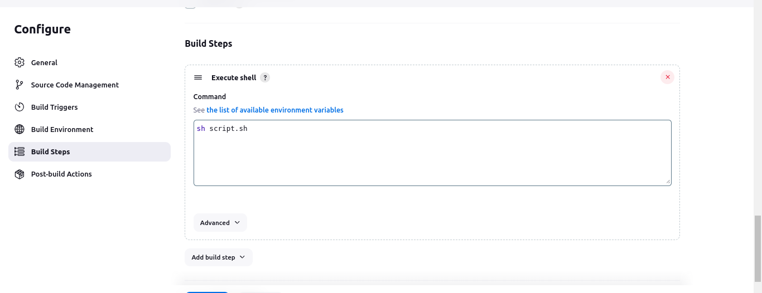.

For executing script.sh file fetched from GitHub private repo.

3. Create Pipeline View to display continious build between Dev Compile and Dev Test.

